**Herramientas básicas**

Fuente: J.E. Hopcroft, J.D. Ullman. Introduction to Automata Theory, Languages, and Computation.

Addison‐Wesley, (1979), pp. 10‐11.

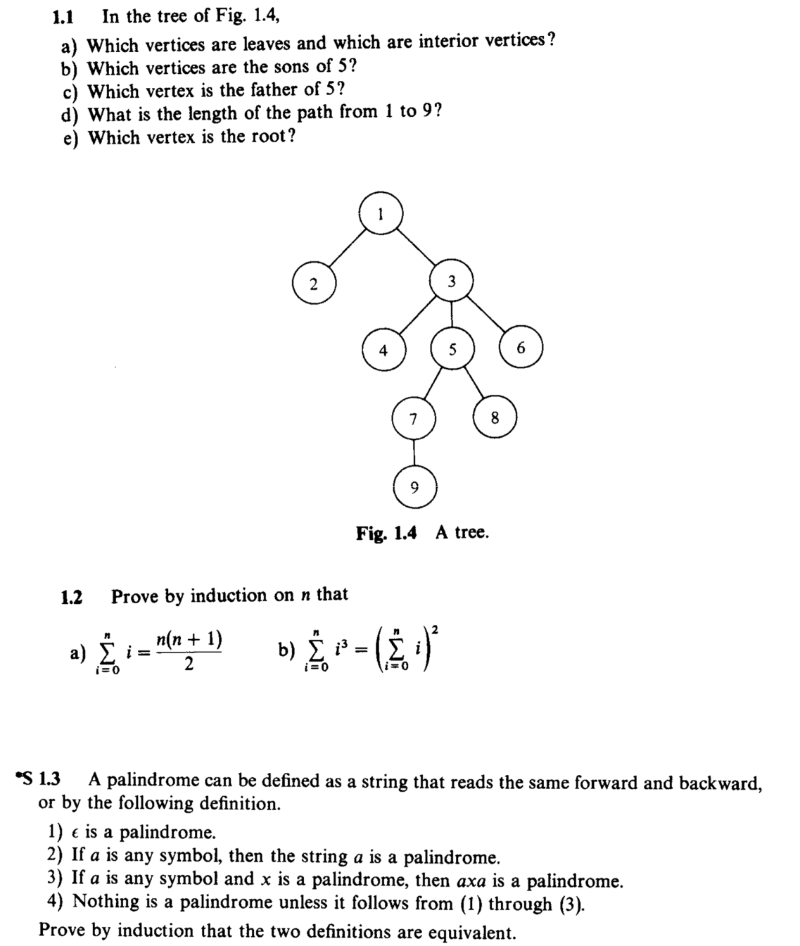

1. Which vertices are leaves and which are interior vertices?
   1. Leaves: 2, 4, 6, 8, 9
   2. Interior vertices: 1, 3, 5, 7
2. Which vertices are the sons of 5?
   1. Sons of 5: 7, 8
3. Which vertex is the father of 5?
   1. Father of 5: 3
4. What is the length of the path from 1 to 9
   1. Length path from 1 to 9: 4
5. Which vertex is the root?
   1. Root: 1

1.2.- Prove by induction that N